**Quiz 4**

1. Ruby Program that prints the Time in different time zones

Ans) #!/usr/bin/env ruby

require 'Time'

now = Time.now

puts now = now.gmtime

puts now = now.localtime

Output:-

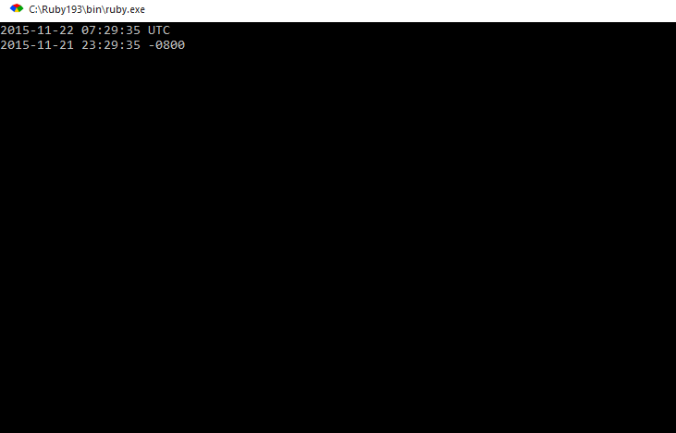

2. Write a program that iterates over an array and builds a new array that is the result of incrementing each value in the original array by a value of 2. You should have two arrays at the end of this program,

The original array and the new array you've created.Print both arrays to the screen using the p method instead of puts.

Ans) #!/usr/bin/env ruby

a = [3,5,7,9,11]

b = a.collect{|x| 2+x}

p a,b

Output:-

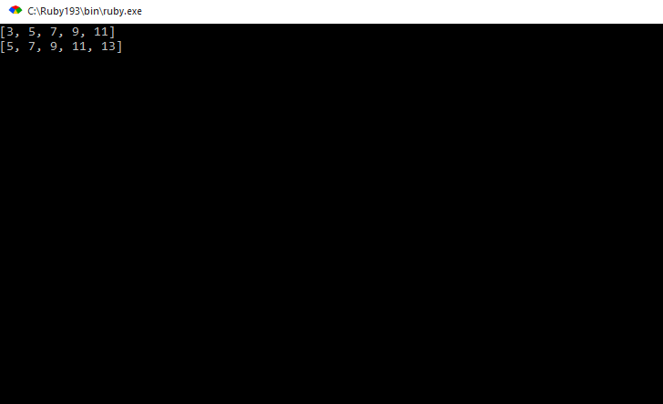

3.Ruby program to find the leap year when start and end year are given.

Ans) #!/usr/bin/env ruby

puts "enter starting year"

starting=gets.to_i

puts "enter ending year"

ending=gets.to_i

(starting..ending).each do |year|

next if year % 4 != 0

next if year % 100 == 0 && year % 400 != 0

puts year

end

Output:-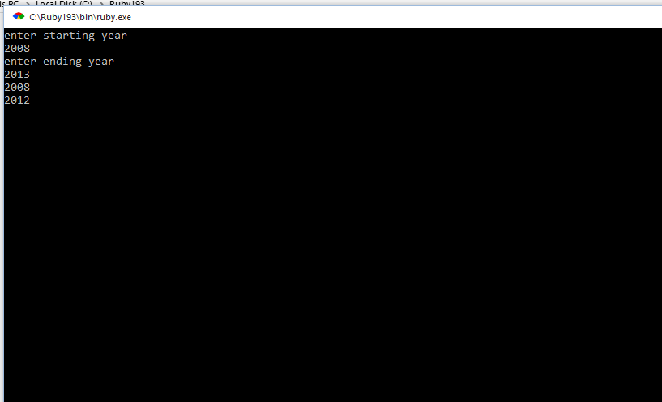

4. Ruby program that takes a numerical value and give the output as Roman number

Ans)

5. Write a your own ruby program that uses a Queue

Ans) #!/usr/bin/env ruby

arr =[4,5,6,7]

print arr.unshift(8)

puts "\nSize of the Queue is:" ,arr.size

print "\nInserting Values:",arr.push(9)

puts "\nSize of the Queue is: " ,arr.size

gets

Output:-

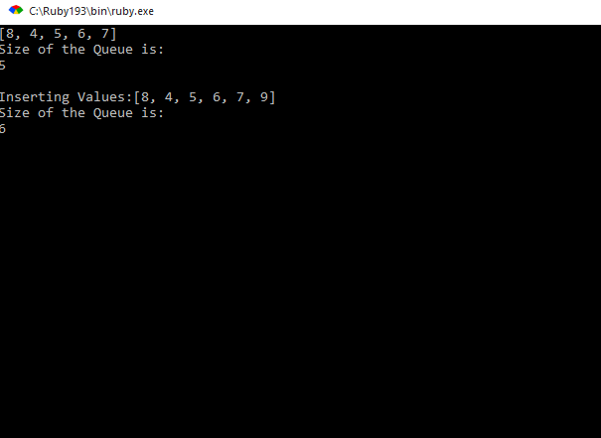

6. Write your own ruby program that uses each_with_index method to iterate through an array that prints each index and value

Ans) #!/usr/bin/env ruby

array = ["India", "Usa", Uk"]

array.each_with_index {|val, index| puts "#{val} => #{index}" }

Output:-

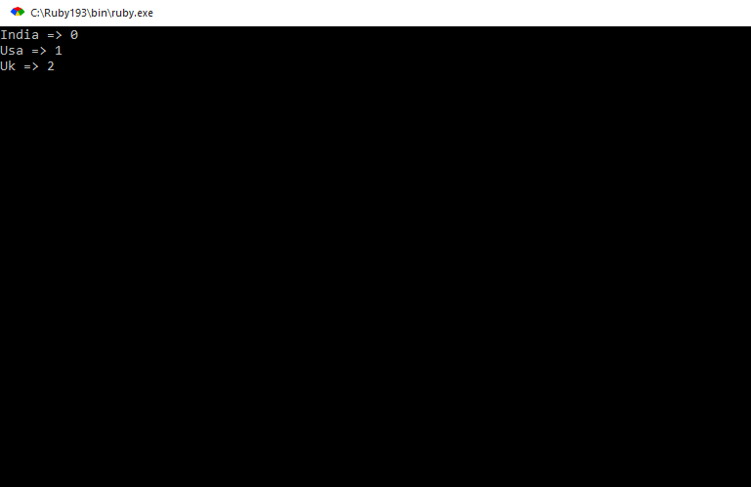

7. Ruby Program that prints if duplicates existing in a array

Ans) a = [1,2,1,3,6,5,6]

duplicate = a.select{ |e| a.count(e) > 1 }

puts duplicate

Output:-

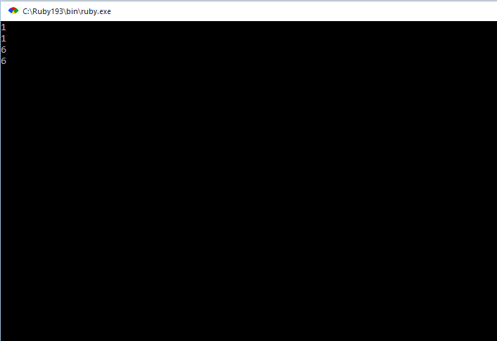

8. Write a Ruby program that prints pascal triangle

9. Write a Ruby program that prints the length of the common string when two strings are compared.

Ans) #!/usr/bin/env ruby

puts "Enter the first string"

string1 = gets.chomp

puts "Enter the second string"

string2 = gets.chomp

if string1 === string2

puts "string length : ",string1.length

else

puts "please Enter the same string"

end

gets

Output:-

